Create Assignments within Blackboard
Note: Blackboard provides an easy and efficient way for instructors to create assignments that allow students to upload directly into the Grade Center. This eliminates the need for students to email their assignments to instructors and offers the instructor one area to access and grade students assignments.

Creating an Assignment

- Go into your Blackboard course.  - Identify where within the course you wish to add the assignment.  - Click the Assessment button.  - From the drop down menu, select Assignment. | 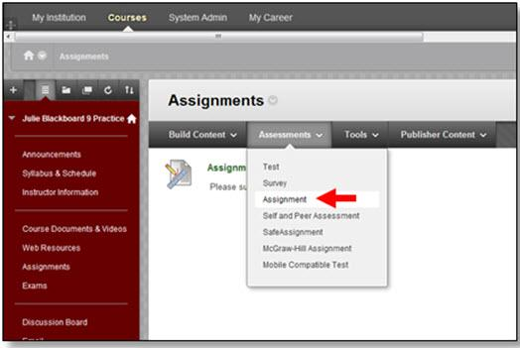

- Within the new window, enter the name of the assignment in the Name and Color field.  - Enter any instructions for the assignment in the Instructions box.  - If you want to attach a document that details the assignment, click Browse My Computer or Browse Course.  Note: This will enable you to upload a document for student viewing. | 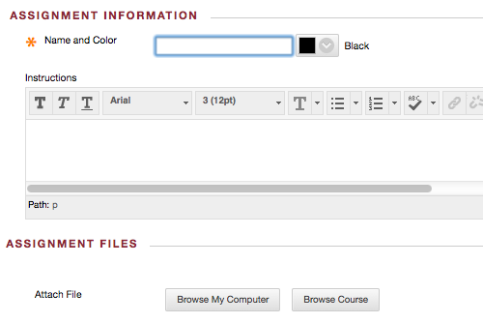

- Click the checkbox for Due Date. Then click the calendar to add a due date and click the clock to add a time in the Due Date field. | 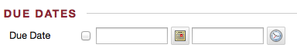
- Under Grading, enter the number of points possible for the assignment within the Points Possible. You can also click Add Rubric.  Note: A rubric must be created within Blackboard in order to add a rubric to the assignment. | 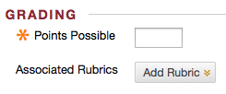
- Click Submission Details to show additional options.  - Set the Assignment Type  - Individual Submission  - Group Submission  - Portfolio Submission  - Determine the Number of Attempts | 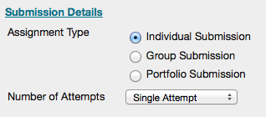
- Click Grading Options to select  - Anonymous Grading or  Note: Anonymous grading hides student names during the grading process.  - Enable Delegated Grading.  Note: Enable Delegated Grading allows you to delegate grading responsibilities to one or more additional grader. | 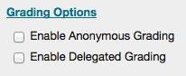
- Click Display of Grades to set  - Primary display and Secondary display (if desired)  - Include in Grade Center Calculations  - Show to students in My Grades  - Show Statistics | 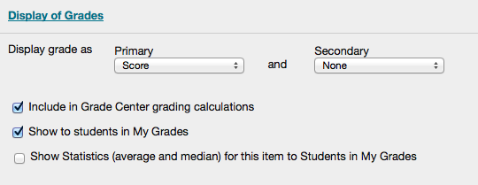
- Under Availability, make sure the checkbox next to Make the Assignment Available is checked.  - If you want to limit the time that this assignment is viewable to the student, select the appropriate dates in the Display After and Display Until fields.  - If you want to track the students who have accessed this assignment, click the Track Number of Views checkbox. | 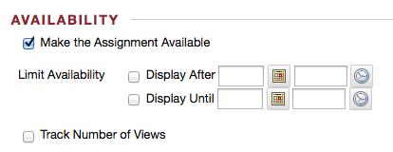
- Click the Submit button. | 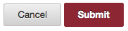

Student Access to the Assignment
Note: To see how students would submit their assignments, see the following documentation: Student Submission for Assignment.

Grading the Assignment

Note: To see how to grade an assignment, see the following documentation:
Grading the Assignment.

