Using GIS Map Report Type:

- Report Layout - Map

  - Report Layout – From the bioXL Home tab, the Report Layout provides an extended tool menu to select 8 different report layout options. Once selected, the report panel will be reset and allow the user to select which report components (grid, chart, text, slicer, gauge or map) they want in each pane. The Map option works with the Zip Code hierarchy to which gives you the ability to view the data selected within a map format.

    - Below is a report using the Application Count measure within the Columns, Zip Code (State) within the Rows and Current Term Set within the slices:

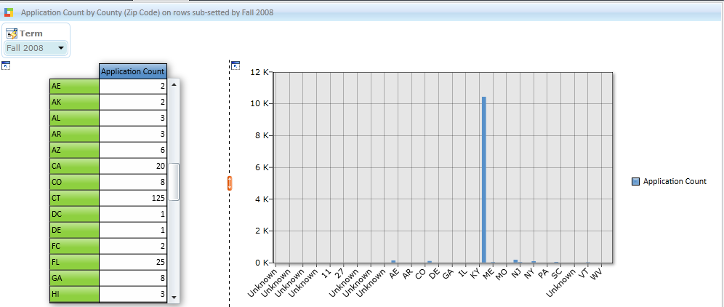

    - 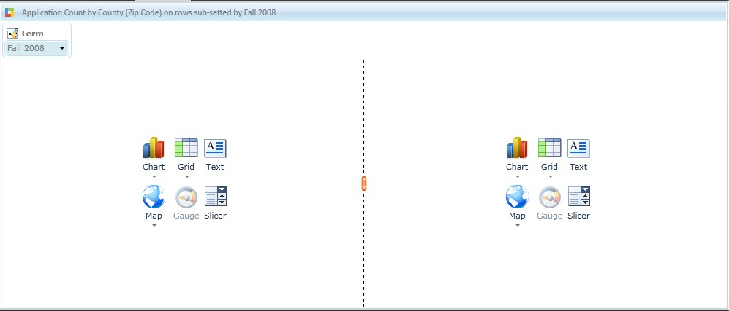To change the chart to use the map feature, click on the Report Layout icon within the Home ribbon panel. Select a display option:

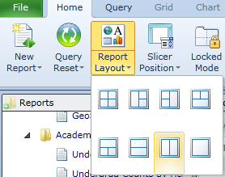

    - Select a Grid for the Left side of the report and then the Map option for the right. The report will look similar below. (Note: it is not required to show a grid with the map)

      - Drill down capabilities can also be used by drilling down on the state.

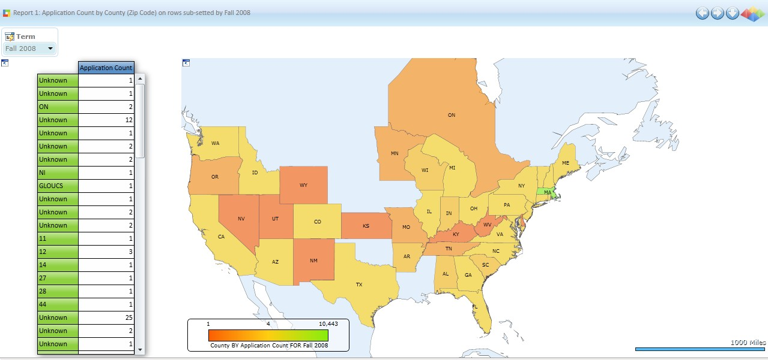

    - Once you have selected the Map report type, the map formatting can be changed by clicking on the Map ribbon panel.

